Annotation de la preuve OCR

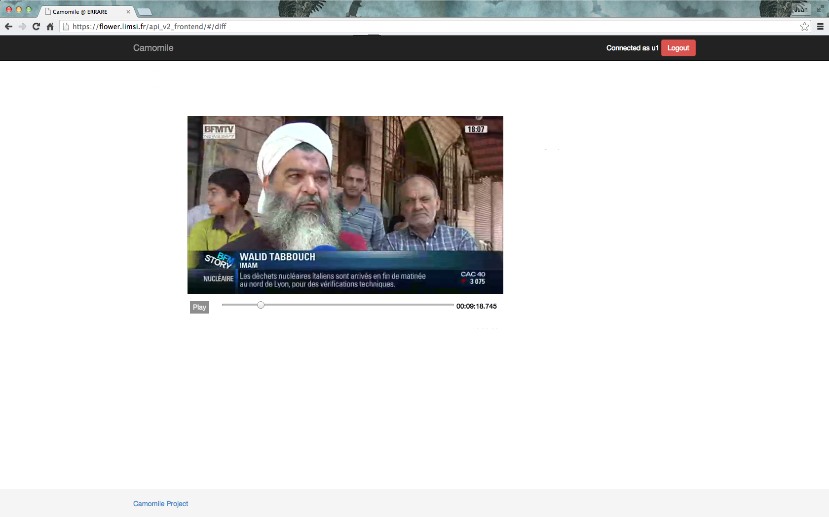

- Correct the name if need.

- Click on the face (you can play the video to find a better image).

- Valid your annotation.

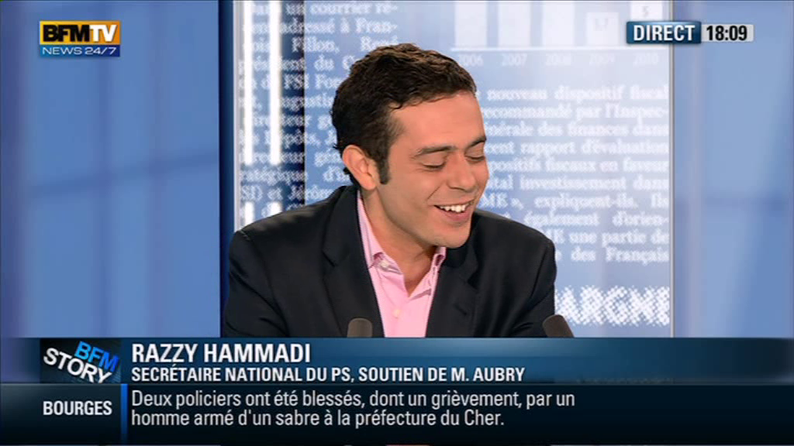

RAZZY HAMMADI

Annotation de la preuve ASR

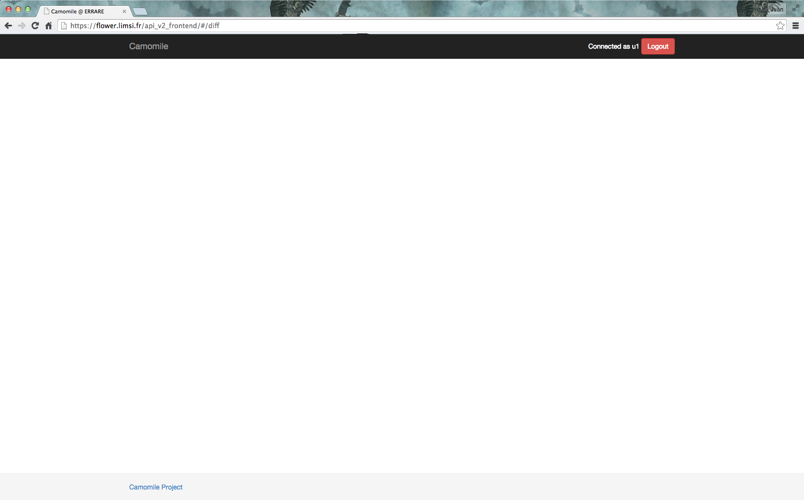

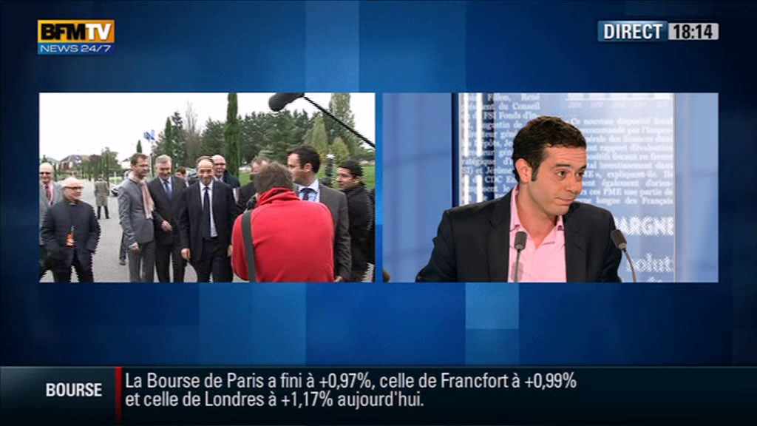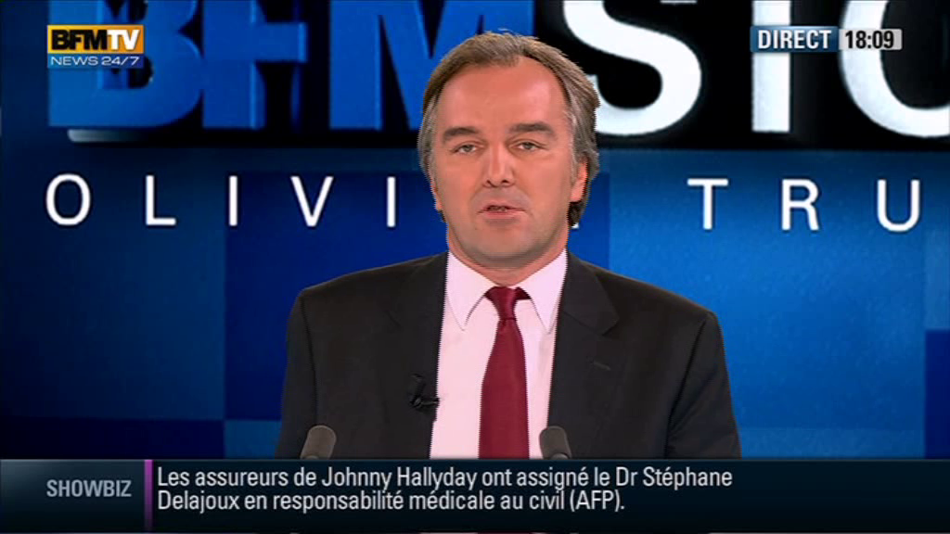

- Correct the name if need.

- Click on the face in the video et the left side (you can play the video to find a better image).

- Valid your annotation.

RAZZY HAMMADI

… Bienvenue « Razzy Hammadi », vous êtes le secretaire nationnal du PS …

Annotation des visages



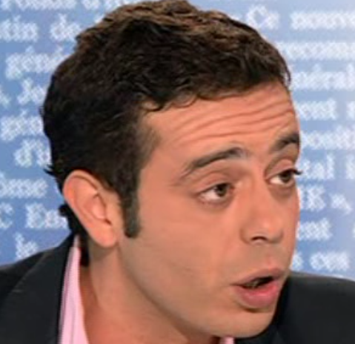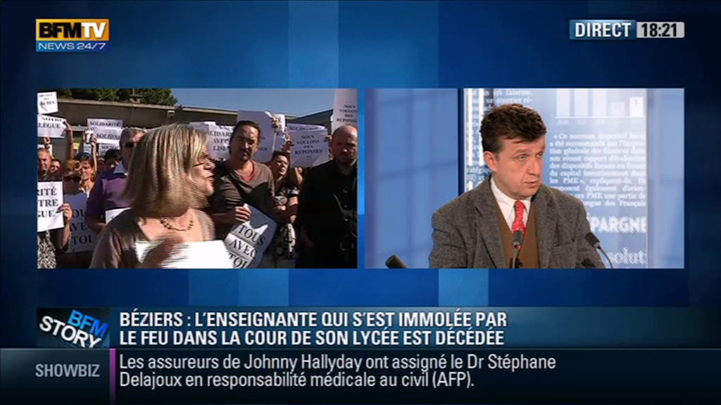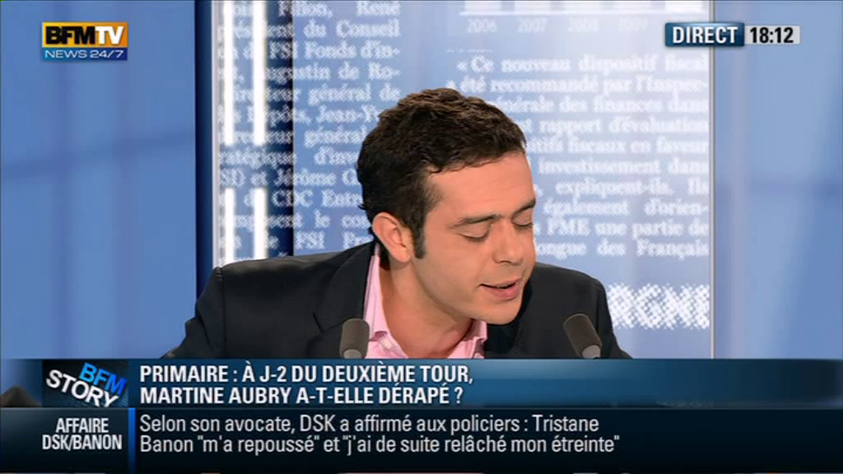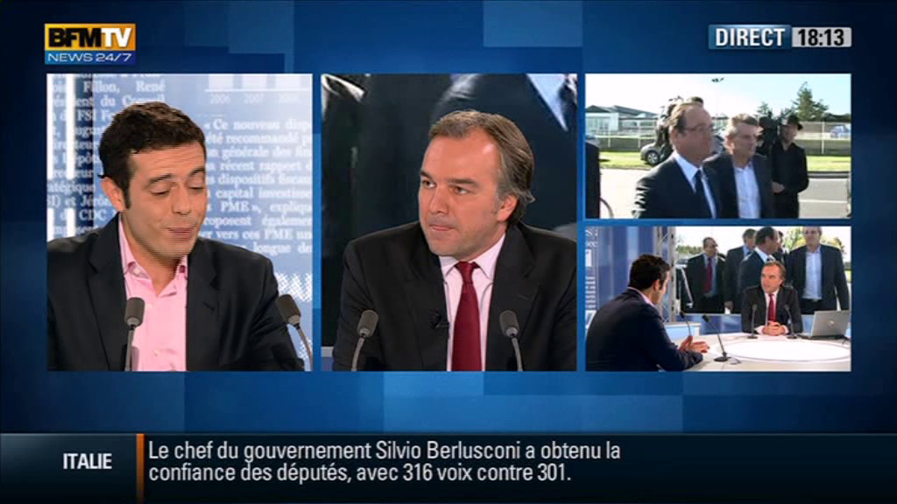

Click on the face of the same person in the video at the left side

Annotation visage parlant





- Is the face surrounded speaks in the shot